**Английский язык**

**10–11 класс**

**Рабочий лист (учащийся)**

***Art object “Sphere”***

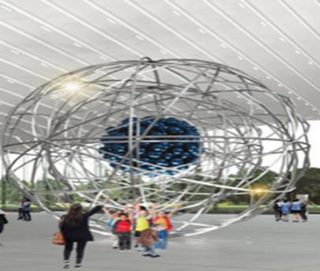

**Task 1. Choose the correct term to complete the sentences:**

|  |  |
| --- | --- |
| ***periodic table*** | ***energy level*** |
| ***metal*** | ***electron*** |
| ***strong nuclear force*** | ***groups*** |
| ***probability*** | ***nucleus*** |
| ***isotopes*** | ***spectral lines*** |

1. Protons and neutrons are found in the __________, in the center of the atom.
2. A(n) ______________ is a negative charge particle.
3. ____________ are atoms or the same elements with different numbers of neutrons.
4. There are four different forces at work inside the atom: electromagnetic force, strong nuclear force, weak force and gravity. The strongest force inside the nuclei is______________.
5. The _______________ is a way of organizing the elements basing on their chemical properties.
6. The first ___________ of an electron cloud has the lowest energy and is closest to the nucleus.
7. The vertical columns of the periodic table are called_______________.
8. A(n)_____________ is a shiny, opaque elementary substance that is a good conductor.
9. Each element emits a characteristic pattern of ________________.
10. If you toss a single penny, the _______________ of “getting heads” is 50%.

**Task 2. Draw a model of an atom that has 5 protons, 6 neutrons, and 5 electrons. Mark the charge of each particle. What element is this?**

|  |
| --- |
|  |

**Answer: _____________________**

**Task 3. Answer the questions:**

1) What kind of particles form the nucleus of an atom?

2) What occupies the most space in an atom, the nucleus or the electron cloud?

3) Which of the four forces inside the nuclei is the strongest?

4) Which of the four forces inside the nuclei is the weakest?

5) If the protons in the nucleus of an atom repel each other due to electromagnetic forces, why the nucleus does not fly apart?

**Answers:**

1. **__________________________________________________________________**

**__________________________________________________________________**

1. **_________________________________________________________**

**_________________________________________________________**

1. **_________________________________________________________**

**_________________________________________________________**

1. **_________________________________________________________**

**_________________________________________________________**

1. **_________________________________________________________**

**_________________________________________________________**

***1st floor. “Modern nuclear industry”***

**Task 4. Match the sustainable development goal (SDG) and the information about it. Some goals may include several information blocks.**

|  |
| --- |
| **SDG** |
| **A)** **Affordable and clean energy** |
| **B) Health and wealth** |
| **C)** **Decent job and economic growth** |
| **D)** **Climate change battle** |
| **E)** **Famine elimination** |
| **F) Clean water and sanitation** |

|  |  |
| --- | --- |
| **Info** | |
| 1. | Due to nuclear energy, Russia saves more than 100 million tons of CO2 equivalent per year, which is about 7% of all greenhouse gas emissions in Russia. (Rosatom analysis) |
| 2. | Every fifth light bulb in Russia is powered by electricity received from nuclear power plants. A nuclear power plant with a capacity of 2x1200MW gives electricity sufficient for a comfortable life of more than 5 million people. |
| 3. | One desalination complex integrated with a nuclear power plant produces 170 thousand cubic meters per day, which makes it possible to fully provide 850 thousand people with water. |
| 4. | Annually tens of millions of patients are diagnosed and treated by means of nuclear medicine. |
| 5. | Existing nuclear facilities replace 1.6 gigatons of carbon dioxide emissions per year, and since they were put into service 66 gigatons of carbon dioxide had been displaced, which is equivalent to two years of global emissions. |
| 6. | One unit of nuclear power plant creates about 3000 jobs with guaranteed employment of people who are over 60 years old, as well as 10,000 jobs in related industries. |
| 7. | 1 kg of uranium fuel for the WWER-1000 reactor produces energy equivalent to energy released during the combustion of 60 tons of oil or 100 tons of coal. |
| 8. | Irradiation of grain seeds leads to a significant increase in yield up to 20%. |

**Answers:**

**A) _______**

**B) _______**

**C) _______**

**D) _______**

**E) _______**

**F) _______**

***Human evolution***

**Task 5. Using the following information, fill in the table below.**

**AGE**

|  |  |  |  |  |  |  |
| --- | --- | --- | --- | --- | --- | --- |
| **A**  Ancient China | **B**  The New Time  (XVI–XVIII centuries) | **C**  The Paleolithic | **D**  Ancient India | **E**  Middle Ages | **F**  Phoenicia | **G**  Renaissance |
| **H**  Ancient Rome | **I**  Ancient Egypt | **J**  Ancient Greece | **K**  XXI century | **L**  Babylon | **M**  The New Time  (XIX century) | **N**  XX century |

**SCIENCE**

|  |
| --- |
| **1.** The Arabic number system (Hindu-Arabic numerals) |
| **2.** Jurisprudence |
| **3.** Fire use |
| **4.** Intensive development of cybernetics, nanotechnology, artificial intelligence |
| **5.** Cuneiform |
| **6.** Anatomy |
| **7.** Navigation |
| **8.** Hieroglyphs |
| **9.** Enlightenment, Industrial Revolution |
| **10.** E = mc2, microprocessors, computers, space, the first spaceflight, nuclear power,  psychiatry, psychology |
| **11.** History, Philosophy, Democracy |
| **12.** Physics, Chemistry, the Modern Atomic theory, Microbiology, Louis Pasteur, Charles Darwin, Pierre Curie and Maria Skłodowska-Curie (Б), Michael Faraday, Dmitri Mendeleev, telegraph, X-ray |
| **13.** Geography, Literature, Astronomy, Chemistry, Scholasticism |
| **14.** The invention of gunpowder |

**ART**

|  |
| --- |
| **I.** The Hanging Gardens of Babylon |
| **II.** Lev Yashin, Kino (band), Lev Gumilev, Sholokhov “Tihiy Don” |
| **III.** Confucius, Li Bai, Daode-jing |
| **IV.** The Olympic games, amphorae, Homer “The Odyssey”, “The Iliad”, Aristophanes “The Birds”, Sophocles “Antigone” |
| **V.** The great pyramids of Giza |
| **VI.** Victor Hugo “Notre Dame de Paris”, Charles Dickens “The Adventures of Oliver Twist”, Rudyard Kipling “The Jungle Book”, Van Gogh “Sunflowers” |
| **VII.** Gladiator fights, aqueduct |
| **VIII.** Chess, the Ramayana, the Mahabharata |
| **IX.** Leonardo da Vinci, Botticelli, Michelangelo, Donatello, Dante Alighieri “Divine Comedy”, Giovanni Boccaccio “The Decameron” |
| **X.** Glass, Tyrian purple (royal purple, imperial purple, or imperial dye) |
| **XI.** Digital art, Pokras Lampas |
| **XII.** Cave painting |
| **XIII.** Montesquieu “The Spirit of Laws”, Voltaire, Jean Jacques Rousseau, Daniel Defoe “Robinson Crusoe”, Jonathan Swift “Gulliver's Travels”, Johann Wolfgang Goethe “Faust”, Johann Sebastian Bach, Ludwig van Beethoven, Wolfgang Amadeus Mozart |
| **XIV.** Gothic architecture, Romanesque architecture |

**Fill in the table**

**3.3 million years ago…… XXI century**

|  |  |  |  |  |  |  |  |  |  |  |  |  |  |  |  |
| --- | --- | --- | --- | --- | --- | --- | --- | --- | --- | --- | --- | --- | --- | --- | --- |
| AGE |  |  |  |  |  |  |  |  |  |  |  |  |  |  |  |
| SCIENCE |  |  |  |  |  |  |  |  |  |  |  |  |  |  |  |
| ART |  |  |  |  |  |  |  |  |  |  |  |  |  |  |  |

***Nuclear medicine***

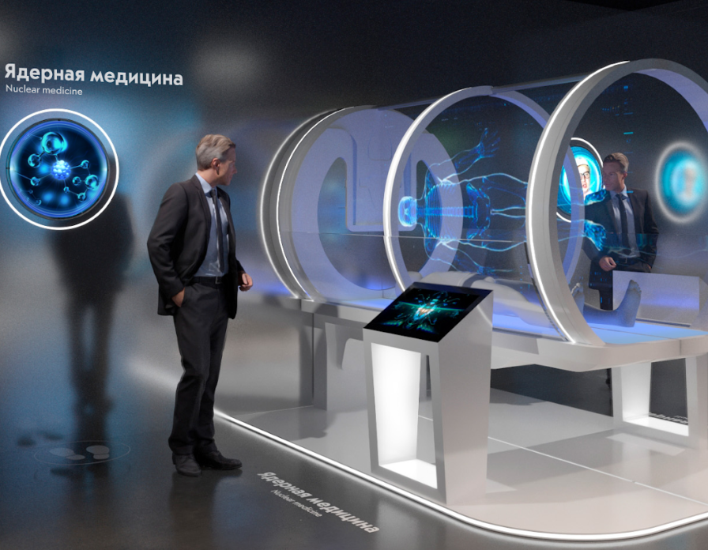

**Task 6. Read the text, choose the name of the disease mentioned in the text.**

*cardiovascular diseases, cancer, hepatitis, stroke (apoplexy), tumor, fracture*

___________is a large group of diseases that can start in almost any organ or tissue of the body when abnormal cells grow uncontrollably, go beyond their usual boundaries to invade adjoining parts of the body and/or spread to other organs. The latter process is called metastasizing and is a major cause of death from __________. A neoplasm and malignant tumor are other common names for _____________.

___________ is the second leading cause of death globally, accounting for an estimated 9.6 million deaths, or one in six deaths, in 2018. Lung, prostate, colorectal, stomach and liver ___________ are the most common types of ____________ in men, while breast, colorectal, lung, cervical and thyroid ____________ are the most common among women.

The _______________ burden continues to grow globally, exerting tremendous physical, emotional and financial strain on individuals, families, communities and health systems. Many health systems in low- and middle-income countries are least prepared to manage this burden, and large numbers of ____________ patients globally do not have access to timely quality diagnosis and treatment. In countries where health systems are strong, survival rates of many types of ___________ are improving thanks to accessible early detection, quality treatment and survivorship care.

**Answer: ____________________**

***Installation “Particle Accelerator”***

**Task 7.** **Bacteria, viruses and microorganisms that make you starve.**

**Approximately 30% of all products in the world do not reach the consumer. Food losses at various stages of the production chain account for one third of all food**. Increasing agro-industrial production and improving its quality are one of the most important tasks of ensuring food security of the Russian Federation. The solution is impossible without implementation of technologies that ensure the growth of production, reducing losses during its storage and processing.

Radiation technologies involving the use of physical methods of plant protection (ionizing and non-ionizing radiation) are one of the most effective and environmentally friendly technologies that require less energy and allow to replace or drastically reduce the use of fumigants and other chemicals. At the same time, the processed products are not contaminated with residual amounts of harmful chemical compounds, there is no thermal destruction of organic compounds.

**Various products can be processed with radiation. Which ones?**

*fish, grain, meat, potatoes, fruit*

1. This product is covered with mold and turns black. ________________________

2. This product loses color. The enlarged image shows helminths that spread toxins, bacteria and viruses. __________________

3. In this product small tick larvae appear and carry the viruses. ________________

4. Even a slight increase in temperature or humidity level can provoke its unwanted germination. ________________

5. This product starts to decay. The enlarged image shows bacteria that spread toxins and viruses. ________________

**Task 8. Why does irradiation of food products prolong their shelf life? Find the incorrect answers.**

1) delays the germination of vegetables and fruits.

2) slows down fruit ripening.

3) accelerates fruit ripening.

4) suppresses the growth of microorganisms.

5) eliminates or reduces the number of insects.

6) leads to thermal destruction of organic compounds.

**Answers: _________________**

***“Atom as a premonition” zone***

**Task 9. Connect the beginning and the end of the sentences so that you get a coherent text.**

|  |  |
| --- | --- |
| **1.** At the end of the nineteenth century, French physicist Henri Becquerel | **A.** the phenomenon discovered by Becquerel — “radioactivity” — and together with her husband they isolated two new radioactive elements — radium and polonium. |
| **2.** Marie Curie and her husband Pierre joined the research, Becquerel consulted them. Marie Curie introduced a new term describing | **B.** out that radioactive rays come from atoms that undergo transformation into atoms of other chemical elements. |
| **3.** A few years later, Ernest Rutherford found | **C.** offered a model of an atom with a nucleus and surrounding electrons, which was later supplemented by other scientists. |
| **4.** Rutherford discovered a new, subatomic world and | **D.** discovered a mysterious physical phenomenon: uranium compounds leave dark imprints on a photographic plate. |

**Answers:**

|  |  |  |  |
| --- | --- | --- | --- |
| **1.** | **2.** | **3.** | **4.** |
|  |  |  |  |

***WWER-1200 reactor with background screens***

**Task 10.** **Read the text with the gaps 1-7. Fill in the gaps with the missing words (A, B, C or D).**

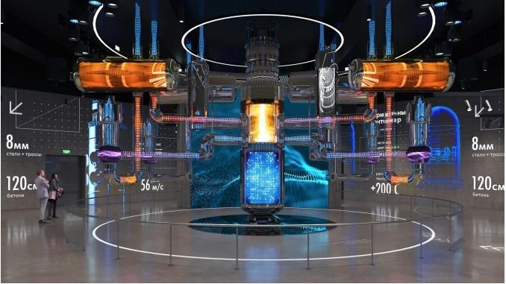Nuclear reactors are hi-tech **1)**____________________ that are used for energy needs, for military purposes, and are also used for transportation needs. In the USSR, the initial theoretical and experimental **2)** _______________ of the launching process, operation and control of reactors were conducted by a group of physicists and engineers under the leadership of academician I. V. Kurchatov.

The first Soviet **3)** _____________ F-1 was built in Laboratory No. 2 of the USSR Academy of Science (Moscow). This reactor was brought to a critical state on December 25, 1946. The F-1 reactor was assembled from graphite blocks and has the shape of a ball with a diameter of **4)** ______________ 7.5 m. In the central part of the ball with a diameter of 6 m, uranium rods are **5)** ______________ in holes in graphite blocks. The F-1 reactor is air-cooled, so it operated at relatively low **6)**___________ levels (up to a megawatt for a short time). The results of research at the F-1 reactor became the basis for projects of more complex industrial reactors.

June 26, 1954 the world's first nuclear power plant with an electric output of 5 MW in the city of Obninsk **7)** __________________.

1. A) installations       B) structures         C) device           D) tools
2. A) tests                 B) studies                C) learning D) monitoring
3. A) turbine              B) engine               C) reactor            D) convector
4. A) approximately   B) about             C) presumably    D) around
5. A) placed               B) located               C) settled              D) brought
6. A) strength             B) might                 C) power            D) energy
7. A) began to act     B) entered service C) opened          D) came into operation

|  |  |  |  |  |  |  |
| --- | --- | --- | --- | --- | --- | --- |
| **1** | **2** | **3** | **4** | **5** | **6** | **7** |
|  |  |  |  |  |  |  |

***“Soviet nuclear industry”***

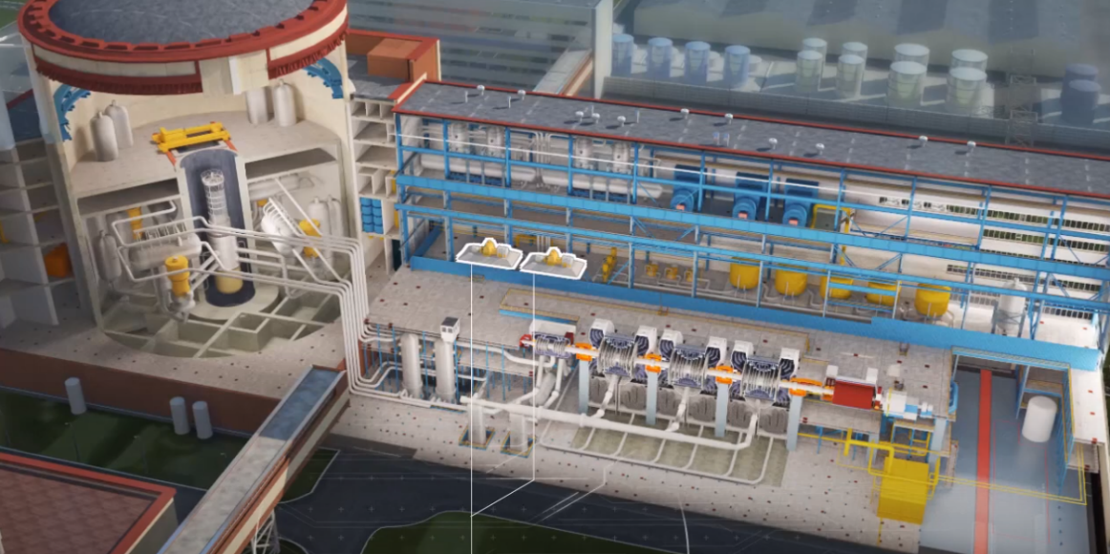

**Task 11. Study the installation of nuclear power unit with WWER-1200 reactor. Do the following tasks:**

1) What is the primary circuit cooling agent of WWER-1200?

А. Water with boric acid

В. Fuel rods

С. Light isotopes

D. Natural uranium

2) What circuit of WWER-1200 power unit is radioactive?

___________________

3) What is not included in the second circuit of nuclear power unit WWER-1200?

А. Condenser

В. Turbine

С. Steam generator

D. Centrifuges

***“Obninsk nuclear power plant control panel”***

**Task 12. Match the name of the parts of the nuclear power plant and the numbers presented in the picture.**

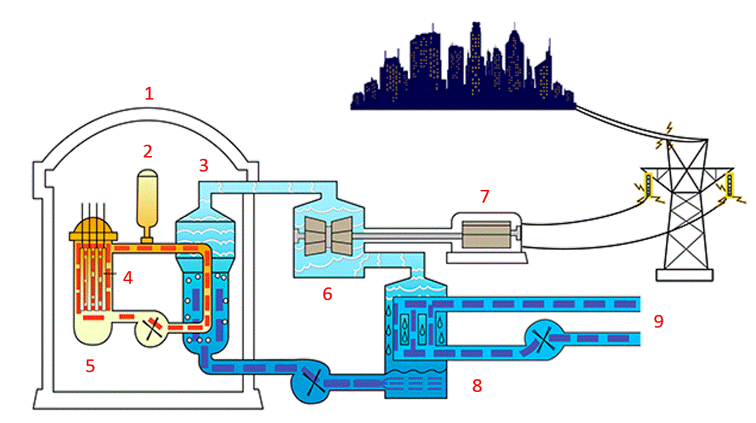

Condenser – ___

Turbine – ___

Reactor – ___

Containment – ___

Control rods – ___

Steam generator – ___

Generator – ___

Cooling water – ___

Pressurizer – ___

***“Installation in spheres” zone***

Robots, space stations, computers – these and other futuristic themes influenced the new style of Soviet architecture. The 1960s were the era of the Soviet science fiction. Books for children and adults, adventure novels and philosophical stories – all of them were dedicated to the wonderful future. The fashion of the 60s makes a real world revolution. The range of food products is expanding. Everyday asceticism is becoming a thing of the past, and people are getting used to taking care of their own comfort.

**Task 13. Read the names that refer to each group. Match the names with their definitions.**

|  |  |  |  |  |
| --- | --- | --- | --- | --- |
| **C:\Users\sazykinaon\Downloads\imgonline-com-ua-Transparent-backgr-vnXR7EFKjmUwTRgI.png** | **C:\Users\sazykinaon\Downloads\imgonline-com-ua-Transparent-backgr-yyHvVB1Vuo5kFX.png** | **C:\Users\sazykinaon\Downloads\imgonline-com-ua-Transparent-backgr-IKk8rI2XUYf.png** | C:\Users\sazykinaon\Downloads\imgonline-com-ua-Transparent-backgr-goMOJQrvjS.png | C:\Users\sazykinaon\Downloads\imgonline-com-ua-Transparent-backgr-oWI3GkmqxEmon.png |
| 1. Аelita | 3. Friendship | 5. Bikini | 7. Burning Abysses | 9. Knizhka |
| 2. Saturn | 4. Pyramidka | 6. Mini | 8. Through Real Time | 10. Panelka |

A. – a device for hair drying

B. – one of the first Soviet science fiction works of literature written in the space opera genre

C. – a very short skirt

D. – a residential building constructed from reinforced concrete slabs

E. – a vacuum cleaner

F. – a processed cheese

G. – collection of fantasy stories

H. – a [two-pie](https://dictionary.cambridge.org/dictionary/english/two-piece)ce [swimsuit](https://dictionary.cambridge.org/dictionary/english/swimsuit) for women

I. – one of the most famous Moscow skyscrapers, resembling a giant open book

J. – a triangular shaped disposable milk carton

|  |  |  |  |  |  |  |  |  |  |
| --- | --- | --- | --- | --- | --- | --- | --- | --- | --- |
| **1** | **2** | **3** | **4** | **5** | **6** | **7** | **8** | **9** | **10** |
|  |  |  |  |  |  |  |  |  |  |